PROJECT REPORT
A report on
Deepfake Detection Using GAN with Confidence Scoring
Submitted for partial
Fulfillment of the requirements for the degree of

Bachelor of Technology
in

Computer Science and Engineering
by

Group No: 31

Rounak Ghosal (16900123071)
Dyutimay Ghosh (16900123177)
Bidisha Maji (16900123170)
Archisman Sinha (16900123021)
Bimal Kr. Mahato (16900123032)

Under the guidance of

Prof. Abhishek Majumdar
Associate Professor, Computer Science & Engineering


Academy of Technology
G.T. Road (Adisaptagram), Aedconagar Hooghly-712121, West Bengal, India

AICTE-approved college Affiliated with
Maulana Abul Kalam Azad University of Technology (MAKAUT), West Bengal


Problem Statement and Objectives:

  - Domain: Artificial Intelligence, Deep Learning, Computer Vision and Cyber Security.
  - Problem Statement:
The rapid advancement of deep learning technologies has led to the creation of highly realistic deepfake images and videos that are difficult to detect with the human eye. These manipulated media pose serious threats such as misinformation, identity misuse, digital fraud, and loss of public trust. Existing detection methods often struggle with real-world robustness and generalization to unseen manipulation techniques.
Therefore, there is a need to develop an AI-based deepfake detection system that can accurately analyze images and videos and provide a reliable confidence score to assess the authenticity of digital media.

  - Objectives:

    - Develop an Ai-based system to detect deepfake images and videos.
    - Utilize GAN-based model to accurately classify real and manipulated content.
    - Provide a confidence score and risk level for reliable decision-making.
    - Design a user-friendly web interface for easy real-time analysis.

  - Feasibility Analysis:

The project is technically feasible as it utilizes GAN-based deep learning models implemented using frameworks such as PyTorch or TensorFlow, along with OpenCV for video frame extraction and preprocessing. Publicly available benchmark datasets like FaceForensics++, DFDC, and Celeb-DF provide diverse and well-structured data for effective model training and evaluation. The system relies on open-source libraries, which significantly reduces development cost and allows flexibility in customization. Additionally, backend integration using Flask or FastAPI enables smooth communication between the detection model and the user interface, supporting scalable and practical deployment.

Literature Review:

- Paper 1:
- Paper name: Deepfake video detection: challenges and opportunities
- Authors: Achhardeep Kaur, Azadeh Noori Hoshyar, Vidya Saikrishna, Selena Firmin, Feng Xia
- Doi: 10.1007/s10462-024-10810-6
- Objective of the Study:
The study "Deepfake video detection: challenges and opportunities" is part of a growing body of research that examines deepfake generation and detection techniques. It begins with the observation that the number and realism of deepfakes have rapidly increased, bringing concerns to politics, security, and privacy. Previous surveys found that while most detection algorithms are data-driven and accurate on benchmarks, their real-world dependability, computational cost, and robustness remain unknown. According to the authors, prior assessments do not sufficiently focus on video deepfakes, temporal factors, or practical deployment difficulties like as computation time and attack resistance.

- Paper 2:
- Paper name: DeepfakeBench: A Comprehensive Benchmark of Deepfake Detection
- Authors: Zhiyuan Yan , Yong Zhang, Xinhang Yuan, Siwei Lyu , Baoyuan Wu
- Doi: 10.48550/arXiv.2307.01426
- Objective of the Study:
The paper "DeepfakeBench: A Comprehensive Benchmark of Deepfake Detection" attempts to address the issue of evaluation gaps in deepfake detection research. The authors discovered that while many detection models indicate high accuracy, their results are difficult to compare
due to differences in datasets, preprocessing methods, and evaluation measures. The lack of

evaluation uniformity leads to uncertainty concerning model performance and real-world generalization.The major goal of this study is to provide a unified benchmark which includes many cutting-edge detectors, standardized datasets, and similar evaluation methodologies. By providing a consistent data pipeline and training framework, the study offers fair comparison and reproducibility of deepfake detection models.

- Paper 3:
- Paper name: Deepfake Detection: a systematic literature review
- Authors: Brian Dolhansky, Joanna Bitton, Ben Pflaum, Jikuo Lu, Russ Howes, Menglin Wang, Cristian Canton Ferrer
- Doi: 10.1109/ACCESS.2022.3154404
- Objective of the Study:
This paper introduces the DFDC dataset, a very large collection of face-swap (deepfake) videos created to improve automatic deepfake identification. It contains over 100,000 fake clips generated from videos of 3,426 paid actors who consented to having their faces manipulated, using several methods including classic Deepfake autoencoders and multiple GAN-based techniques.To mimic social media conditions, the authors captured a variety of source videos in natural environments, inserted fake faces into the videos, and applied realistic overlays and distortions. They also organized a global challenge where thousands of teams trained deepfake detection models using this dataset. The results indicate that models trained on DFDC may generalize effectively to real “in-the-wild” deepfakes, although deepfake detection remains a challenging problem.

- Paper 4:
- Paper name: DF40: Toward Next-Generation Deepfake Detection
- Authors: Zhiyuan Yan, Taiping Yao, Shen Chen, Yandan Zhao, Xinghe Fu, Junwei Zhu,
Donghao Luo, Chengjie Wang, Shouhong Ding, Yunsheng Wu, Li Yuan
- Doi: 10.52202/079017-0925
- Objective of the Study:
By addressing dataset bias and inadequate cross-dataset generalisation in current
models, the study &quot;DF40: Toward Next-Generation Deepfake Detection&quot; seeks to
enhance the performance of deepfake detection systems. The authors present DF40, a
massive benchmark dataset that includes over a million photos and over 100,000
videos produced with forty distinct deepfake methods. The dataset contains a variety
of manipulation techniques, including synthesis, editing, and face swapping.
Improving model robustness and standardising evaluation processes for detection
performance are the main goals of the study. In practical situations, it helps to improve
detection reliability. The method still has issues with computational complexity and
thedynamic nature of deepfake generation methods, though.

- Paper 5:
- Paper name: Deepfake Detection Using Deep Learning Methods
- Authors: Arash Heidari, Nima Jafari Navimipour, Hasan Dag, Mehmet Unal
- Doi: 10.1002/widm.1520
- Objective of the Study:
This study provides a comprehensive survey of deepfake detection techniques based on deep
learning methods and analyzes their effectiveness, strengths, and limitations. The research
reviews various detection approaches, including image-based, video-based, audio-based, and
hybrid multimedia detection systems. It evaluates different deep learning models such as
convolutional neural networks, recurrent neural networks, GAN-based detection methods, and
transfer learning techniques. The study also examines feature extraction methods such as
visual features, temporal features, biological signals, and forensic artifacts used in detection
systems. The authors identify key challenges in deepfake detection, including poor

generalization, high computational requirements, lack of robustness, and difficulties in real-
world deployment. The research aims to provide a structured overview of existing techniques
and identify research gaps to support the development of more efficient and reliable deepfake
detection systems.

- Paper 6:
- Paper name: Multi-Attentional Deepfake Detection
- Authors: Hanqing Zhao, Wenbo Zhou, Dongdong Chen, Tianyi Wei, Weiming Zhang,
Nenghai Yu
- Doi:10.48550/arXiv.2103.02406
- Objective of the Study:
This study aims to enhance deepfake detection accuracy by identifying subtle and
localized facial manipulation artifacts using multiple attention mechanisms. Unlike
traditional binary classification approaches, the research treats deepfake detection as a
fine-grained classification problem. The proposed model uses multiple spatial
attention heads and texture enhancement modules to focus on important facial regions
such as the eyes, mouth, and boundaries. By extracting both global semantic and local
texture features, the method improves the detection of highly realistic manipulated
images. The approach enhances model sensitivity to small forgery patterns that are
often missed by standard CNN models. Overall, the study seeks to develop a more
accurate and robust deepfake detection framework through attention-based feature
learning.

- Paper 7:
- Paper name: Deepfake Detection Using the Rate of Change between Frames Based on Computer Vision
- Authors: Gihun Lee and Mihui Kim
- Doi: 10.3390/s21217367
- Objective of the Study:
This study focuses on detecting deepfake videos by analyzing temporal inconsistencies
between consecutive frames. It identifies that deepfake generation often introduces unnatural
changes in facial texture, motion, and continuity across frames. The proposed system extracts
frames, detects faces, calculates similarity metrics such as MSE and SSIM, and analyzes
feature variations between frames for classification. Unlike traditional CNN-based methods
that rely primarily on spatial features, this approach emphasizes temporal analysis to detect
distortions in motion patterns. The method aims to improve video-based deepfake detection
accuracy by capturing frame-level inconsistencies. Overall, the study proposes an alternative
detection strategy that focuses on dynamic changes rather than static image features.

- Paper 8:
- Paper name: Hybrid ResNeXt and LSTM Model for Enhanced Deepfake Detection on the
FaceForensics++ Dataset
- Authors: Vaishali Bankar, Diksha R. Pawar, Pravin L. Yannawar
- Doi: 10.5281/zenodo.18074289
- Objective of the Study:
This study proposes a hybrid deep learning model combining spatial and temporal
feature analysis to improve deepfake detection accuracy. The ResNeXt architecture is
used to extract spatial features from individual video frames, while LSTM networks
analyze temporal dependencies between frames. The system detects visual
inconsistencies such as abnormal textures and lighting, as well as motion irregularities
like unnatural blinking or facial movements. By integrating frame-level and sequence-
level learning, the model overcomes limitations of approaches that rely solely on
spatial or temporal features. The research aims to enhance robustness and improve
detection performance against complex video manipulations. Overall, the study
emphasizes the importance of combining multiple feature types for reliable deepfake
detection.

Gap Identification:
- A review of existing research highlights several common limitations in deepfake detection systems. Although many models achieve high accuracy on benchmark datasets, they often fail to generalize across unseen datasets. For example, models trained on FaceForensics++ perform well on similar data but show reduced accuracy when tested on Celeb-DF or real-world social media videos. This indicates poor cross-dataset generalization.
- Limited real-world robustness is another major gap. Many detection systems are evaluated on clean, well-structured datasets, but real-world deepfakes contain compression artifacts, lighting variations, background noise, and social media distortions. For instance, models trained on high-resolution videos often struggle when analyzing compressed WhatsApp or YouTube videos.
- High computational complexity also limits practical deployment. Hybrid models combining CNN and LSTM architectures improve accuracy but require significant GPU resources, making real-time detection difficult. This becomes a challenge when deploying systems for live video calls or streaming platforms.
- Many approaches focus only on visual features and ignore multimodal signals such as audio inconsistencies or lip-sync mismatches. For example, some systems detect face blending artifacts but fail to identify voice cloning or speech manipulation.
- Dataset limitations are also common. The DFDC dataset mainly focuses on face-swap videos and may not fully represent newer techniques such as diffusion-based generation. As deepfake generation methods evolve, detection systems struggle to adapt to new manipulation styles.
Overall, these gaps demonstrate the need for a robust, computationally efficient, and adaptable deepfake detection framework capable of handling real-world conditions and evolving generation techniques.

4.Problems Addressed by Our Project:

- Poor Cross-Dataset Generalization: Existing models often overfit to specific datasets. Our system is trained and evaluated using multiple benchmark datasets (e.g., FaceForensics++, DFDC, Celeb-DF) to improve generalization and robustness.
- Lack of Confidence-Based Decision Making:Many systems only provide a hard Real/Fake label.Our system generates a probability-based confidence score, allowing more transparent and graded decision-making instead of binary output.
- High Computational Complexity in Hybrid Models:Some approaches combine CNN + LSTM or multi-attention networks, increasing computational cost. Our approach focuses on a streamlined GAN-based discriminator model to balance accuracy and efficiency.
- Scalability and Deployment Challenges:Many systems remain research-only prototypes. Our architecture supports frontend–backend integration (Flask/FastAPI) for practical web-based deployment.

5. Workflow:

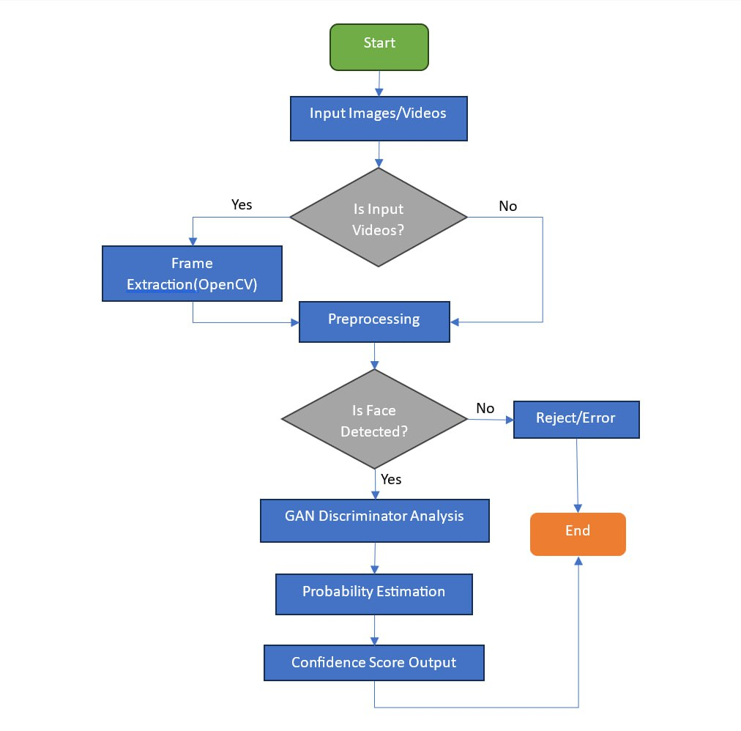

Figure 1: Proposed System Architecture

6. Technologies Used in the Project:
- Python
Python is used as the core programming language for implementing the deep learning model, preprocessing pipeline, and system integration. It provides extensive support for AI and computer vision libraries.
- PyTorch / TensorFlow
These deep learning frameworks are used to build and train the GAN-based detection model. They provide efficient GPU support and flexible model development tools.
- GAN (Discriminator Model)
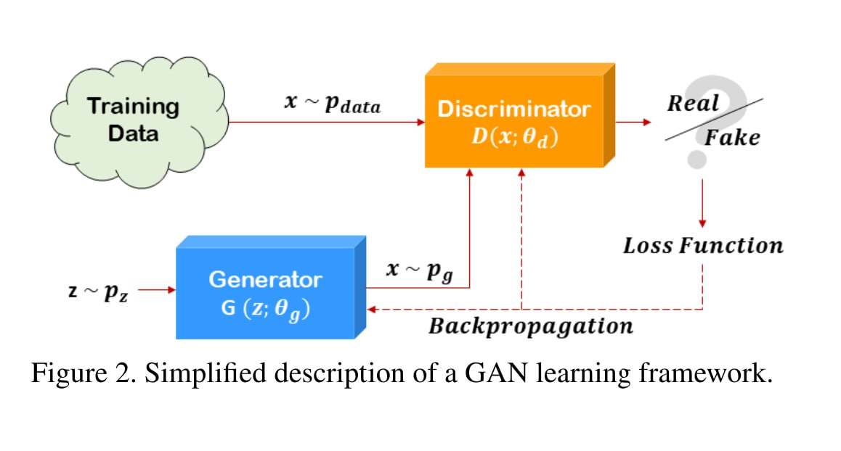
A Generative Adversarial Network (GAN) consists of two neural networks: the Generator (G) and the Discriminator (D). The Generator takes random noise z∼pz​ and produces fake images x=G(z,θg) attempting to mimic real data. The Discriminator receives both real images x∼pdata​ and fake images generated by G, and predicts whether the input is real or fake by computing a probability D(x,θd). During training, G tries to fool D, while D tries to correctly distinguish real from fake samples, forming a min–max game optimized using a loss function and backpropagation. After training, the Discriminator becomes highly effective at identifying manipulated images, which is useful for deepfake detection.

- CNN (Convolutional Neural Network)
CNN layers are used for extracting spatial features such as textures, edges, and facial inconsistencies from images and frames.
- OpenCV
OpenCV is used for video frame extraction, image preprocessing, resizing, and normalization before feeding data into the model.
- MTCNN
MTCNN is used for face detection and cropping, ensuring that the model focuses only on relevant facial regions instead of the entire image.

- Flask / FastAPI
These backend frameworks enable communication between the AI model and the frontend interface through API endpoints.
- React / HTML / CSS / JavaScript
These technologies are used to build the user interface, allowing users to upload images or videos and view detection results.

7.Datasets to be used :

- Video Datasets

- FaceForensics++
- DFDC (DeepFake Detection Challenge)
- Celeb-DF (v2)
- UADFV
- Deepfake-TIMIT
- DeeperForensics-1.0
- ForgeryNet

- Image Datasets

- DFFD (Digital Face Manipulation Dataset)
- FFHQ (Flickr-Faces-HQ)
- iFakeFaceDB
- 100K Faces Generated by AI
- ForgeryNet

8. Progress Overview from Phase–1:
In the first phase of the project, detailed research was conducted on Deepfake Detection systems and Artificial Intelligence-based media analysis techniques. A literature review of 8 research papers was completed to understand different deepfake generation methods, GAN architectures, CNN-based classifiers, temporal analysis methods, and benchmark datasets used in existing systems.
The research helped identify several limitations in current deepfake detection approaches, such as:
- Poor cross-dataset generalization
- Limited robustness against real-world deepfakes
- High computational complexity
- Lack of confidence-based prediction systems
Based on the literature review, the project objectives and system workflow were finalized. The proposed system architecture for Deepfake Detection using GAN with Confidence Scoring was designed successfully. Technologies such as Python, PyTorch, OpenCV, GAN, EfficientNet-B4, and LSTM were selected for implementation. Public benchmark datasets including Celeb-DF v1 and Celeb-DF v2 were finalized for model training and evaluation.

9. Optimization and Current Development:
During the current phase, dataset collection, preprocessing, and model implementation were completed. A structured database was created by organizing real and fake media samples into separate directories for efficient training and evaluation.
Approximately:
- 3000 real samples
- 3000 fake samples
were used from the processed datasets. Data filtering techniques were applied to remove corrupted, duplicate, blurred, and low-quality samples to improve overall dataset quality and model performance.
A complete preprocessing pipeline was implemented using OpenCV and Albumentations. The preprocessing

steps included:
- Video frame extraction
- RGB color conversion
- Face cropping and alignment
- Image resizing
- Normalization
- Tensor conversion
To improve model robustness and reduce overfitting, several data augmentation techniques were applied:
- Horizontal flipping
- Color jittering
- Brightness and contrast adjustment
- Gaussian noise addition
The proposed Deepfake Detection framework was implemented using a GAN-based architecture consisting of:
- U-Net based Generator
- EfficientNet-B4 based Discriminator
- LSTM-based Video Discriminator for temporal video analysis
The EfficientNet-B4 model was used for extracting deep spatial facial features, while the LSTM model analyzed frame-level temporal inconsistencies in videos. Binary Cross Entropy Loss and L1 Loss functions were implemented for model optimization and reconstruction consistency.
Training optimization techniques included:
- Adam Optimizer
- CUDA GPU acceleration
- Batch processing using DataLoader
- Random dataset sampling
- Checkpoint saving and loading system
These optimizations improved training efficiency, model stability, and overall detection performance.

10. Graph and Performance Analysis:

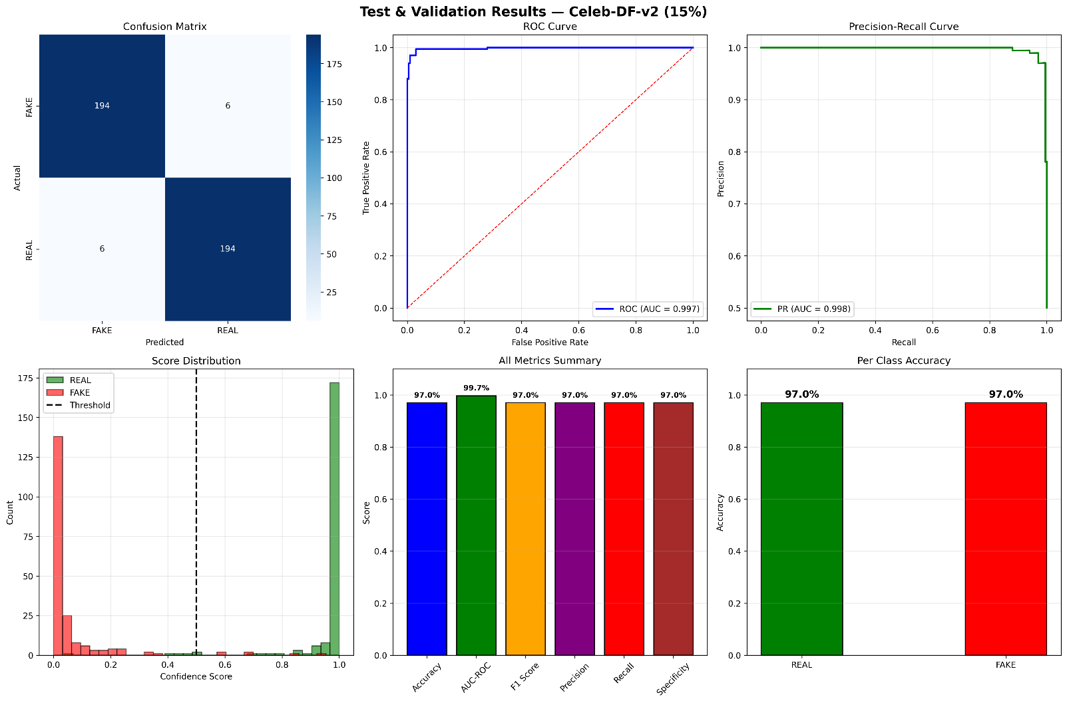

The dataset was divided into:
- 70% for training
- 15% for testing and validation
Several evaluation graphs were generated, including:
- Confusion Matrix
- ROC Curve
- Precision-Recall Curve
- Confidence Score Distribution Graph
The model was evaluated using Accuracy, AUC-ROC, F1-Score, Precision, Recall, and Specificity metrics.
Performance Results
- Accuracy: 97%
- AUC-ROC: 99.7%
- F1-Score: 97%
- Precision: 97%
- Recall: 97%
- Specificity: 97%
The system successfully classified real and fake media with high confidence and reliability.

11.Summary:
The project successfully implemented a GAN-based Deepfake Detection and Confidence Scoring system capable of identifying manipulated images and videos with high accuracy. Major development stages including literature review, dataset collection, data preprocessing, model training, optimization, and evaluation were completed successfully using Celeb-DF datasets.
Advanced deep learning architectures such as U-Net Generator, EfficientNet-B4 Discriminator, and LSTM-based temporal analysis were integrated to improve both spatial and video-level deepfake detection
performance. Data augmentation, filtering, and preprocessing techniques further enhanced model robustness

and generalization capability.
Performance evaluation using metrics such as Accuracy, AUC-ROC, F1-Score, Precision, and Recall demonstrated strong classification capability, achieving approximately 96–97% confidence and accuracy score. The generated evaluation graphs and confidence-based predictions confirmed the effectiveness and reliability of the proposed system.
The current progress provides a strong foundation for future real-time deployment, frontend-backend integration, and further enhancement of the deepfake detection framework.
12.Future Work Plan:

The next phase of the project will focus on improving the overall system performance and deployment capability. Future development plans include:

Frontend and backend integration using Flask/FastAPI

Real-time deepfake detection system implementation

Cross-dataset robustness testing on additional benchmark datasets

Explainable AI integration such as Grad-CAM for visualization of manipulated regions

Optimization for faster inference and reduced computational complexity

Extension towards multimodal deepfake detection including audio analysis

Deployment of the complete system with a user-friendly interface for practical usage

10. References:

- Deepfake Detection: A Systematic Literature Review. DOI: 10.1109/ACCESS.2022.3154404
- The DeepFake Detection Challenge (DFDC) Dataset. DOI:10.48550/arXiv.2006.07397
- Multi-attentional Deepfake Detection. DOI: 10.48550/arXiv.2103.02406
- Deepfake video detection: challenges and opportunities . DOI:10.1007/s10462-024-10810-6
- DeepfakeBench: A Comprehensive Benchmark of Deepfake Detection . DOI:10.48550/arXiv.2307.01426
- DF40: Toward Next-Generation Deepfake Detection. DOI: 10.52202/079017-0925

- Deepfake Detection Using Deep Learning Methods. DOI: 10.1002/widm.1520
- Hybrid ResNeXt and LSTM Model for Enhanced Deepfake Detection on the
FaceForensics++ Dataset . DOI: 10.5281/zenodo.18074289
- Deepfake Detection Using the Rate of Change between Frames Based on Computer Vision
DOI: 10.3390/s21217367
- PyTorch Official Documentation https://pytorch.org/docs/stable/index.html
- TensorFlow Official Documentation https://www.tensorflow.org/api_docs
- https://github.com/yuezunli/celeb-deepfakeforensics?tab=readme-ov-file
- https://ai.meta.com/datasets/dfdc/
- https://github.com/EndlessSora/DeeperForensics-1.0/tree/master/dataset
- https://github.com/yinanhe/forgerynet
- https://github.com/Daisy-Zhang/Awesome-Deepfakes

……………………………………………………….
Signature of Project Guide
Date:

Signature of the students:

……………………………………………………….

……………………………………………………….

……………………………………………………….

……………………………………………………….

……………………………………………………….

